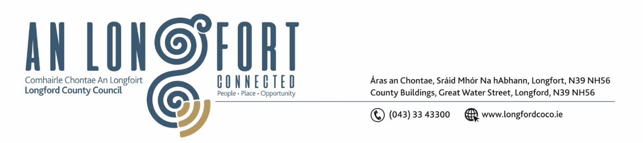

**LONGFORD MUNICIPAL DISTRICT**

**Minutes of Meeting of Longford Municipal District**

**held in the Council Chamber Aras an Chontae and via MS Teams**

**on Wednesday, 24 July 2024 at 11am**

**CATHAOIRLEACH**: Councillor Seamus Butler

**MEMBERS PRESENT**: Councillors Peggy Nolan, Uruemu Adejinmi, Gerry Hagan, Martin Monaghan, Kevin Hussey, Niall Gannon

**IN ATTENDANCE**: Ms. Louise Kiernan, A/Director of Services

Mr. Brian Faughan, Executive Engineer

Ms. Lorraine McKee A/Senior Executive Officer

Ms. Caroline Doyle, Local Health Homes Co Ordinator

**MEETINGS**

**ADMINISTRATOR:**  Ms. Claire McNabola

**APOLOGIES:** Mr. John Brannigan

Mr. David McNiff

1. **ADOPTION OF MINUTES – AS CIRCULATED**

On the proposal of Councillor Peggy Nolan seconded by Councillor Uruemu Adejinmi it was unanimously agreed to adopt Minutes of Meeting of Longford Municipal District held on Wednesday, 22 May 2024 as circulated.

On the proposal of Councillor Peggy Nolan seconded by Councillor Martin Monaghan it was unanimously agreed to adopt Minutes of Longford Municipal District Annual Meeting held on 24 June 202

1. **MATTERS ARISING FROM MINUTES**

None

1. **DECLARATION OF INTEREST BY MEMBERS**

None

1. **CONSIDERATION OF DRAFT STANDING ORDERS FOR LONGFORD MD**

On the Proposal of Councillor Martin Monaghan and seconded by Councillor Uruemu Adejinmi the draft standing orders for Longford Municipal District were adopted.

1. **MANAGEMENT REPORT – as circulated**

Councillor Martin Monaghan raised concerns about the resurfacing works and re instatement of road markings on the Newtownforbes to Rooskey Road at Ballagh Bridge.

Councillor Nolan raised concern once again about the ongoing works on the Battery Road and traffic delays.

Brian Faughnan confirmed that Hedge Cutting will begin in next two weeks and answered any other questions raised by the members.

1. **INTRODUCTION TO NEW LOCAL HEALTHY AGE FRIENDLY HEALTHY HOMES CO ORDINATOR**

Cathaoirleach Councillor Seamus Butler together with the Members welcomed newly appointed Local Age Friendly Healthy Homes Co Ordinator – Caroline Doyle.

Caroline provided the Members with a brief overview of the Programme and what’s involved, contact details etc.

The Members also thanked Mary Carey for all her hard work and commitment to the Longford MD area during her time in the role and wished her every success in Co. Meath.

1. **CONSIDERATION OF PART 8 – THE MALL OUTDOOR FACILITIES UPGRADE, LONGFORD**

On the proposal of Councillor Peggy Nolan, seconded by Councillor Gerry Hagan the Part 8 as presented was approved.

The members collectively welcome the development and requested that all funding streams be exhausted to utilise and further develop the 14 acre site acquired at the Mall facility.

1. **NOTICE OF MOTIONS**

**The following Notice of Motion was proposed by Councillor Seamus Butler, and seconded by Councillor Uruemu Adejinmi**

That Longford Municipal District agrees a 5-year footpath rehabilitation programme with the Executive and Engineering staff commencing in Autumn 2024.

**Response:**

A draft footpath rehabilitation programme will be prepared in the Autumn with the consideration and agreement of the members.

**The following Notice of Motion was proposed by Councillor Gerry Hagan, and seconded by Councillor Peggy Nolan**

I call on Longford MD to carry out resurfacing works and re instatemet of road markings on the Newtownforbes to Rooskey Road at Ballagh Bridge.

This stretch of road is in a very poor state of Repair and is an accident waiting to happen as road markings are completely disappeared.

**Response:**

Road resurfacing works on the N-4 close to Ballagh bridge which includes road markings were tendered earlier this year. A tender assessment was carried out and recommendations were sent to the TII for approval. Longford County Council are currently awaiting sanction from the TII to appoint a contractor.

**The following Notice of Motion was proposed by Councillor Gerry Hagan, and opposed by Councillor Martin Monaghan**

I call on Longford Municipal District to request Bus Eireann to move bus stop from outside the church in Newtownforbes Village to further up the street near what was formerly Bohan's.

**Response:**

The bus stop in Newtownforbes village was relocated to the front of the church earlier this year after a period of almost 18 months discussion with various groups such as the Tidy Town’s, residents in the village, Bus Eireann and the NTA. An inspector from the NTA and a roads engineer from Longford County Council agreed the current location was the optimal location for the bus stop given the engineering constraints at alternative locations within the village.

This concluded the business of the meeting.

**Signed: ____________________**

**Claire McNabola,**

**Meetings Administrator.**

**Confirmed and adopted at Longford Municipal District Meeting held on the 15 October 2024.**

**Signed: _______________**

**Cathaoirleach**